The steps to create Create Azure Devops Environment and configuring Azure Devops Git Repository, configure on your local git to implement this upload few test files on same are as follows:

Initially login to the azure credentials, and open Azure Devops Organization service.

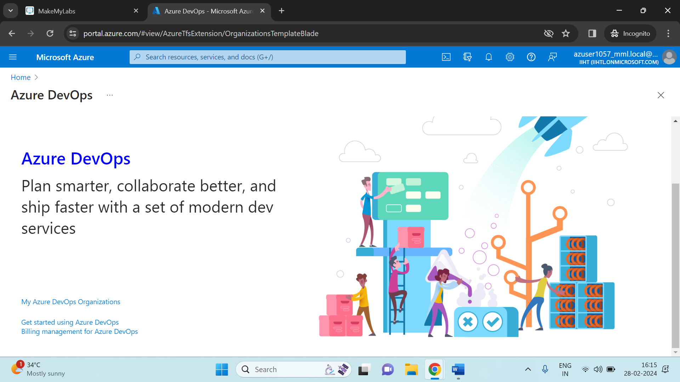

Then Click on My Azure DevOps Organizations:

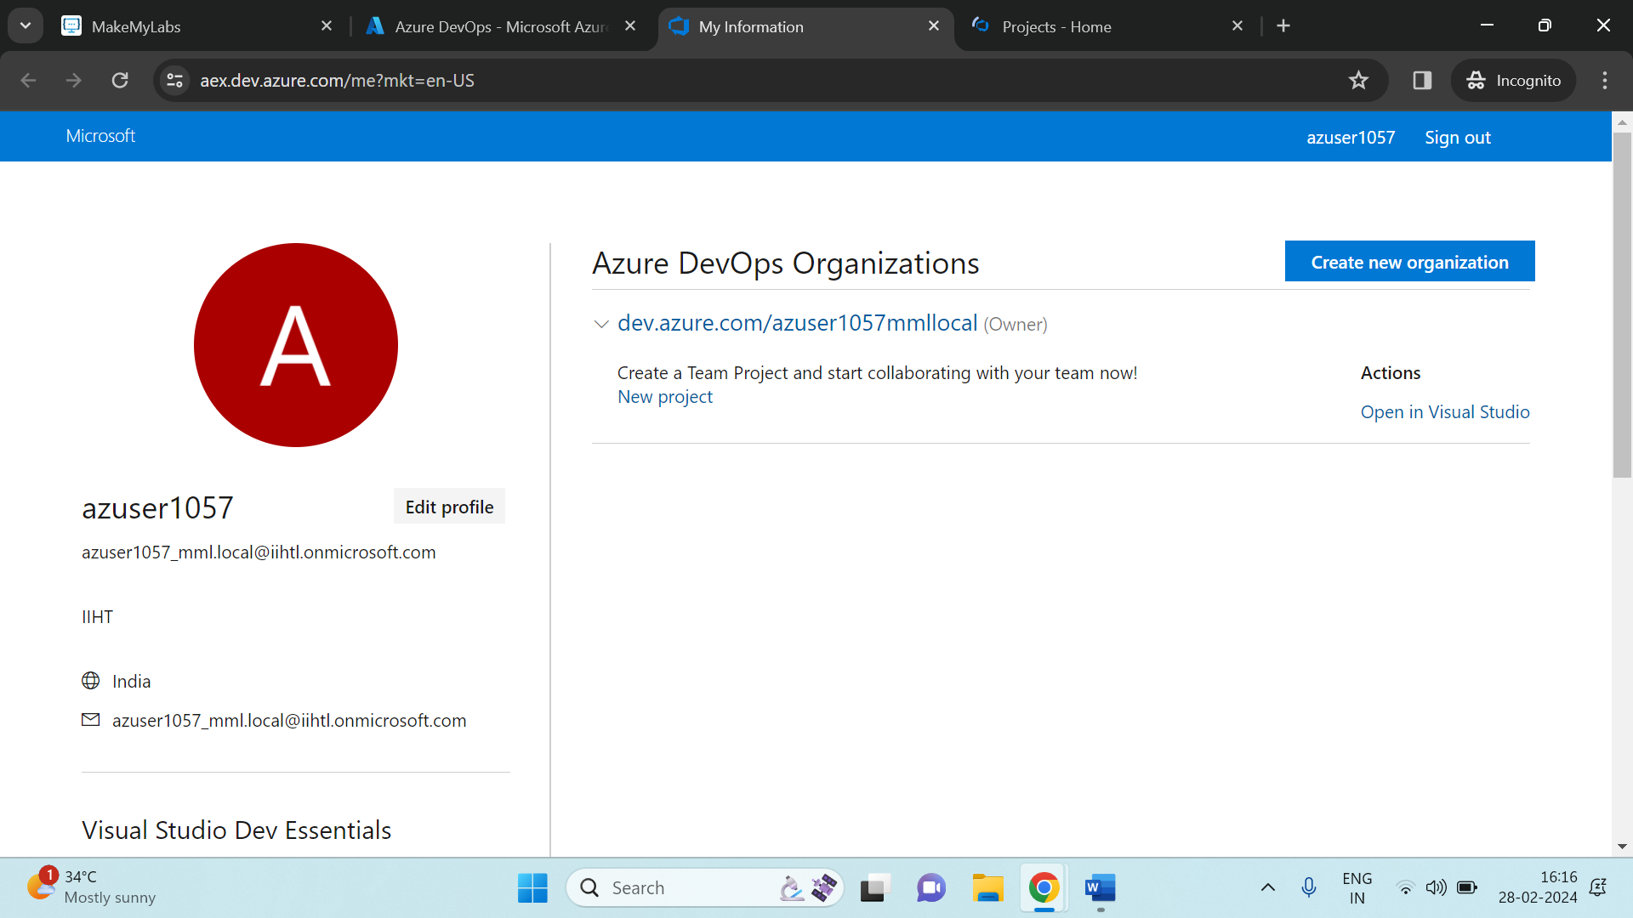

Click on the exsiting organization, and fill the details as shown below:

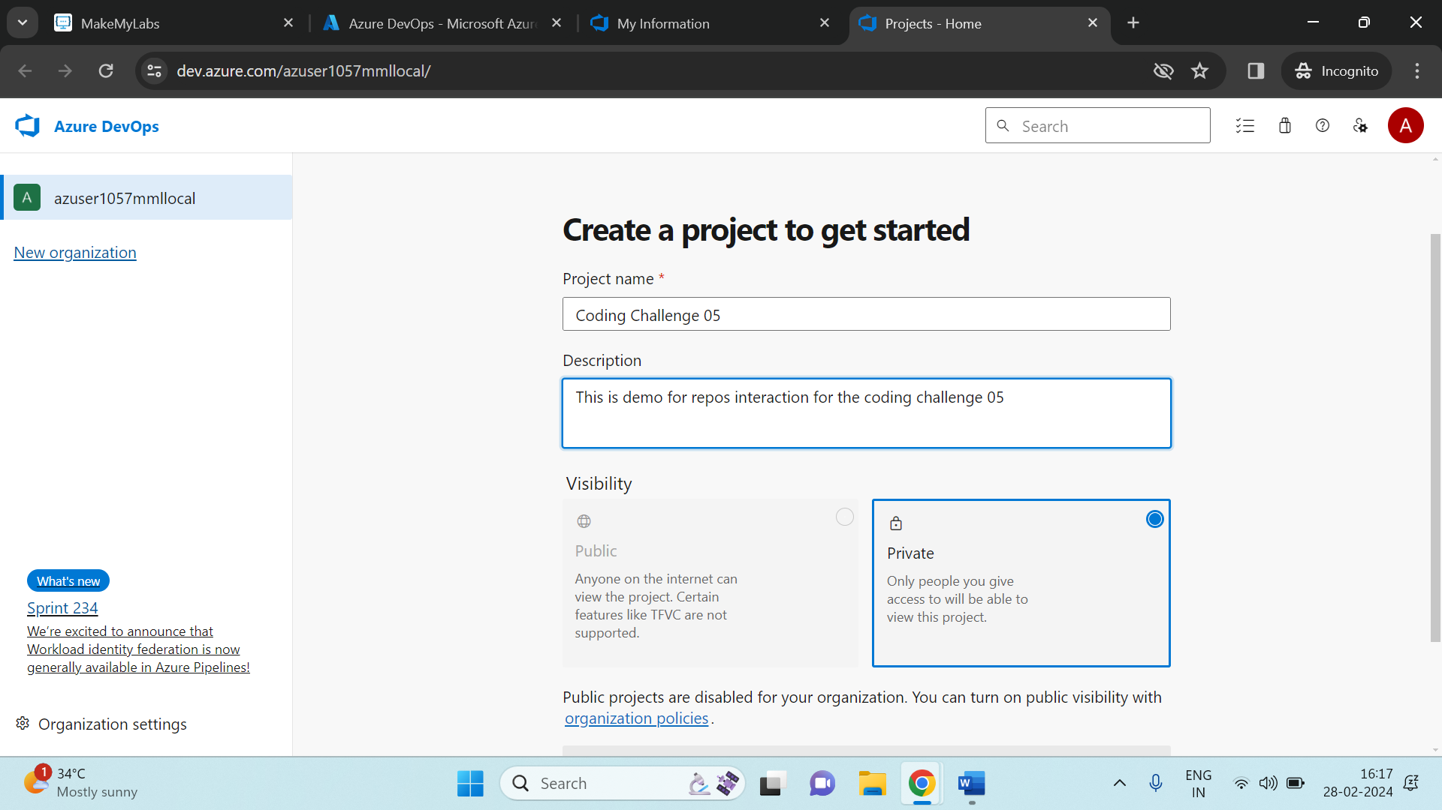

Below shows us the Azure Devops Interface

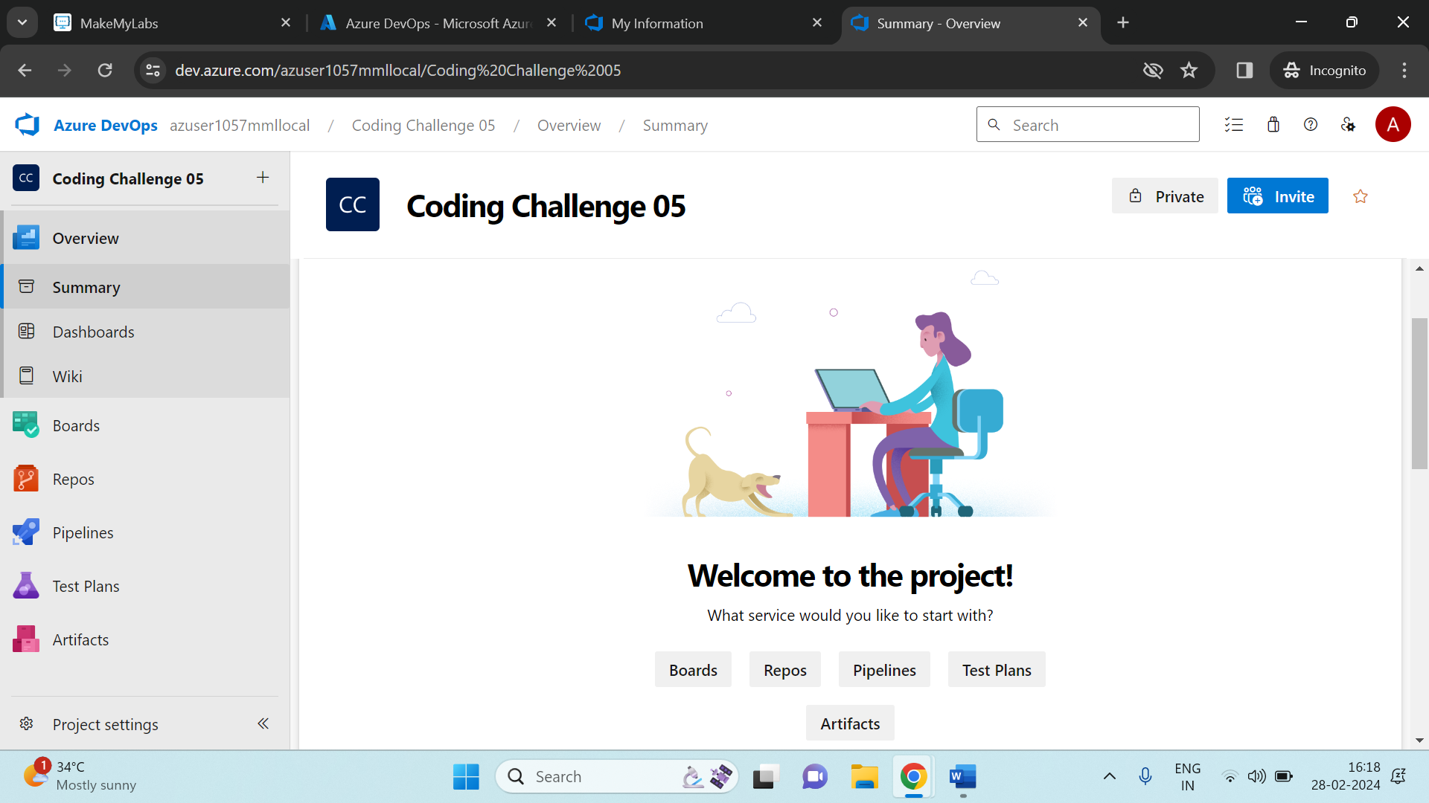

Click on Repos (Repositories) and copy the link from Clone to your computer.

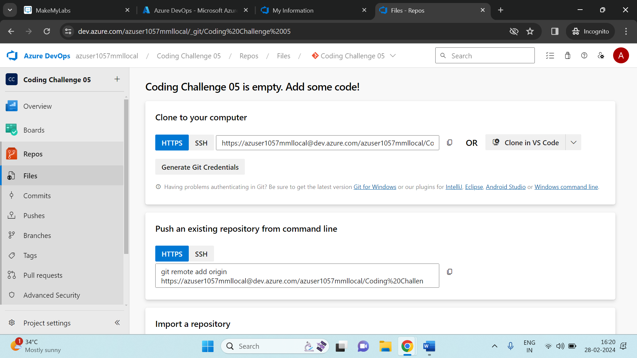

Later on, open Git Bash which is installed in your local system (Git bash help us to update the code or move the code from the local repos to Centralised repos like GitHub, BitBucket and so on).

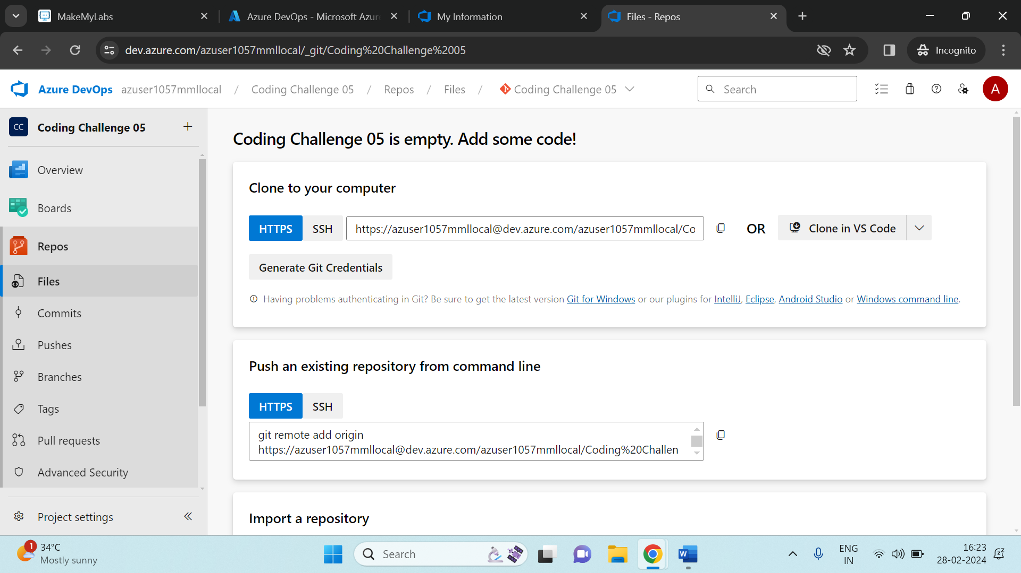

From here onwards, we will write some series of steps related to interaction of git bash with the azure repos as shown in the given picture.

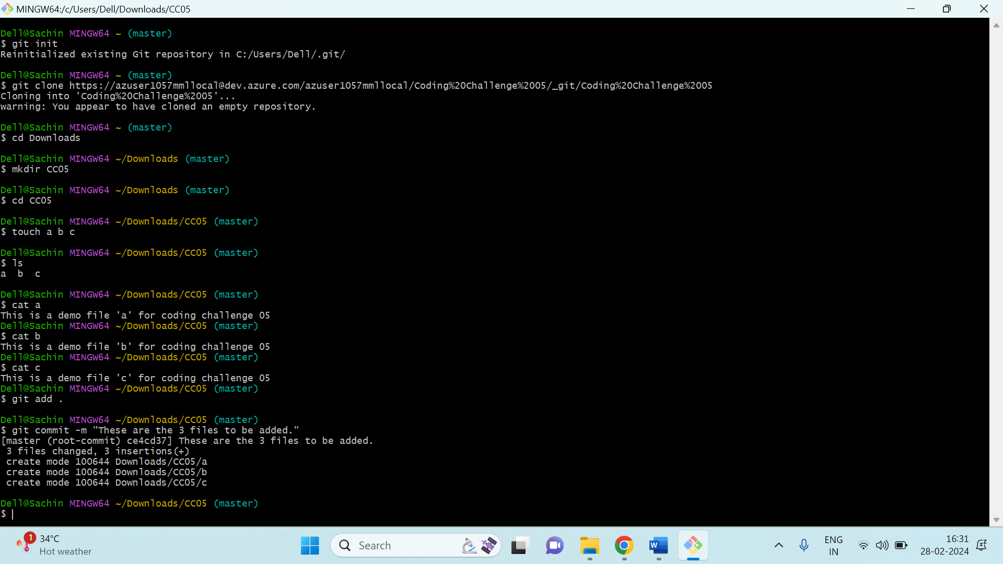

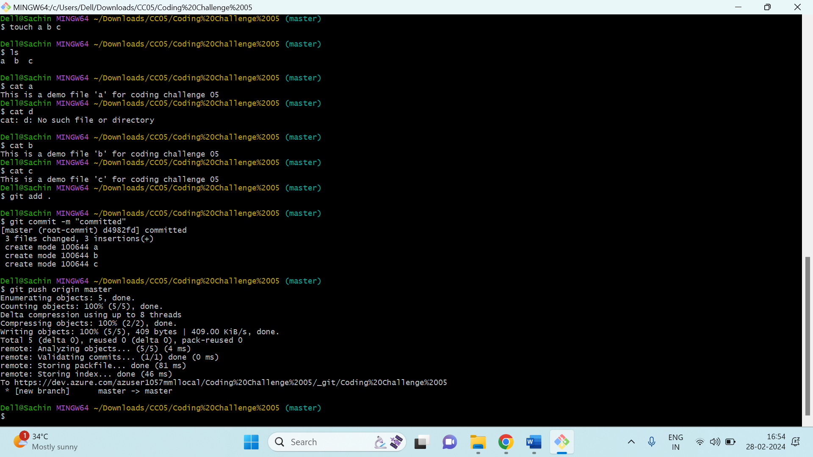

The steps which I have followed in the above 2 pictures are:

* The first step is to initialize the git using the command “**git init**”
* Then clone the azure repo using command “**git clone**”
* Then go to some path inside your local directory (here I have taken a Downloads as my path where I will create a folder and insert some raw files) by using “**cd Downloads**”
* Make a folder inside the Downloads named as **CC05** using command “**mkdir CC05**”, then change your directory to that path.
* Later create .txt file using command “**touch**” command and create 3 files as shown the above pictures.
* Insert some raw data inside each file and to see what we have added to each file we can run a command “**cat**” in the git bash.
* Later on, we need to perform “**GIT PUSH”** operation to push the files to the Azure repos.
* We have totally 3 commands in the git push operations, namely:

1. “**git add .**” (which adds all the changes).
2. “ **git commit -m “Message”** ” (Here we are committing the changes and now it is staging area).
3. “**git push origin master**” (Here we will push the file from the staging area to the Centralized Repos).

* Then you see here the file are been shifted to the azure repos:

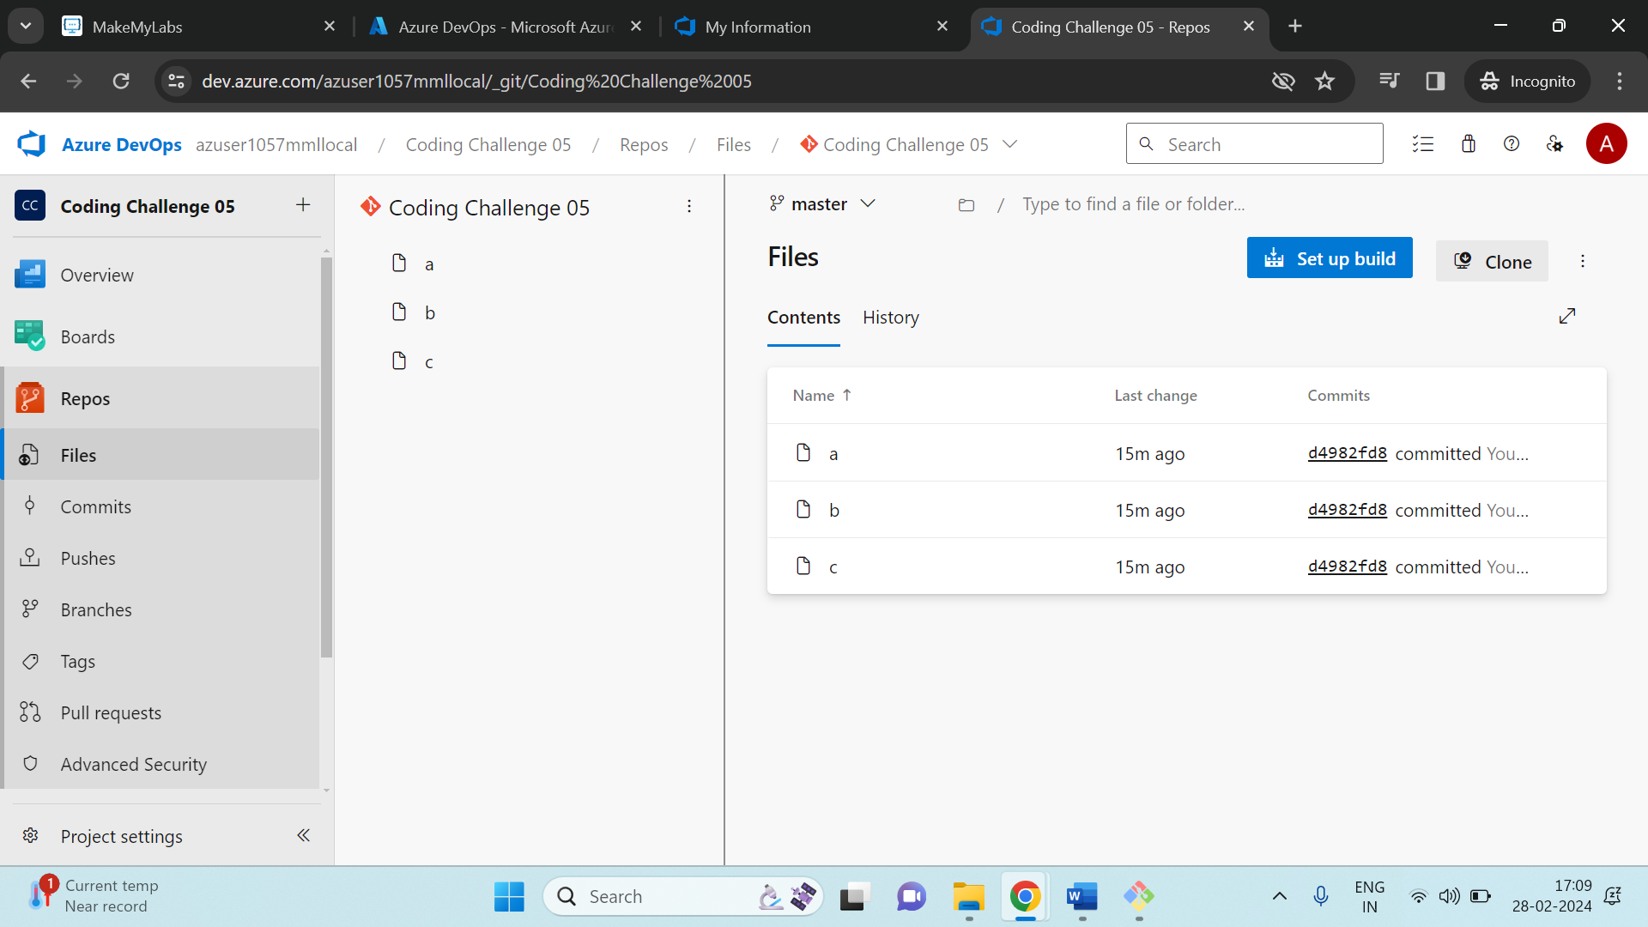

The below pic represents the local file which I have created.

